# NETFLIX SQL

## --Q1 Count the number of movies vs tv shows

select count(*) as total_content, type

from netflix

group by type

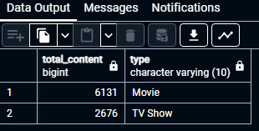

## --Q2 Find the most common rating for movies and TV shows

Select type, rating

from

(select type, rating, count(*),

rank() over(partition by type order by count(*) desc) as ranking

from Netflix group by 1, 2 ) as t1

where ranking = 1

## --Q3 List all the movies released in the year 2020

select * from netflix

where type = 'Movie' and release_year = 2020

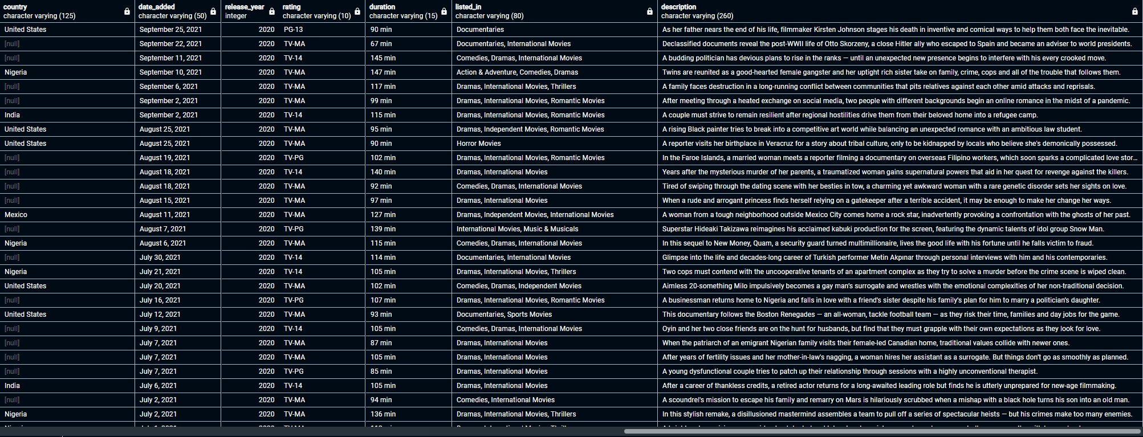

## --Q4 find the top 5 countries with the most content on Netflix

select UNNEST(string_to_array(country, ',')) as new_country,

count(show_id) as total_content from netflix

group by 1

order by 2 desc

limit 5

## --Q5 Identify the longest movie

SELECT title, duration FROM netflix

WHERE type = 'movie' AND duration LIKE '%min%'

ORDER BY CAST(REGEXP_REPLACE(duration, '[^0-9]', '', 'g') AS INTEGER) DESC

LIMIT 1;

## --Q6 find content added in the last 5 years

select * from netflix

where to_date(date_added, 'Month DD, YYYY') > current_date - interval '5 years'

## --Q7 find all the movies/tv shows by director 'Rajiv Chilaka'

select title, type from netflix

where director IliKE '%Rajiv Chilaka%'

## --Q8 List all TV shows with more than 5 seasons

SELECT *,

split_part(duration, ' ', 1) AS sessions

FROM netflix

WHERE type = 'TV Show' AND CAST(split_part(duration, ' ', 1) AS INTEGER) > 5;

## --Q9 Count the number of content items in each genre

SELECT unnest(string_to_array(listed_in, ',')) AS genre,

COUNT(show_id) AS total_content

FROM netflix

GROUP BY genre;

## --Q10 find each year and the average number of content release by India on Netflix. --Return Top 5 year with highest average content release!

SELECT EXTRACT(YEAR FROM to_date(date_added, 'Month DD, YYYY')) AS Yearr,

COUNT(*) as yearly_content,

count(*)::numeric/(select count(*) from netflix where country= 'India')::numeric *100 as average_content

FROM Netflix WHERE country = 'India'

GROUP BY Yearr;

## --Q11 list all movies that are documentaries

SELECT title, release_year, type

FROM netflix

WHERE listed_in ILIKE '%documentaries%' and type = 'Movie';

## --Q12 find all the content without a director

select * from netflix

where director IS null

## --Q13 Find how many movies actor 'Salman KHan' APPEARED in last 10 year

select * from netflix

where casts ILIKE '%Salman Khan%' and release_year > extract(year from current_date) – 10



## --Q14 Find the top 10 actors who have appeared in the highest numbers of movie produced in India

SELECT UNNEST(string_to_array(casts, ',')) AS ACTORS,

COUNT(*) AS total_content

FROM netflix

where country ilike '%India%'

GROUP BY 1

order by 2 desc

limit 10

## --Q15 Categorize the content based on the presence of the keyword ' Kill' and 'Voilence' in the description field.

## --Label content containing these keywords as 'bad' and all other content as 'Good.' Count how many items fall into each category.

SELECT

title,

release_year, description,

CASE

WHEN description ILIKE '%kill%' OR description ILIKE '%violence%'

THEN 'Bad Film'

ELSE 'Good Film'

END AS Category

FROM netflix;

